(Problem-solving): Grammar:

1. The Grammar Rules
- S → AB
- A → aA | ε (where ε is the empty string)
- B → bB | b

2. Step-by-Step Derivation (Leftmost)
To reach the string "aab", we derive as follows:
- S → AB (Start with the root)
- S → (aA)B (Expand A to get the first 'a')
- S → a(aA)B (Expand A again to get the second 'a')
- S → aa(ε)B (Expand A to ε because we have enough 'a's)
- S → aaε(b) (Expand B to 'b' to finish the string)
- Result: "aab"

3. Visual Parse Tree
In a parse tree, the internal nodes are non-terminals, and the leaf nodes (read left-to-right) form the yield/string.
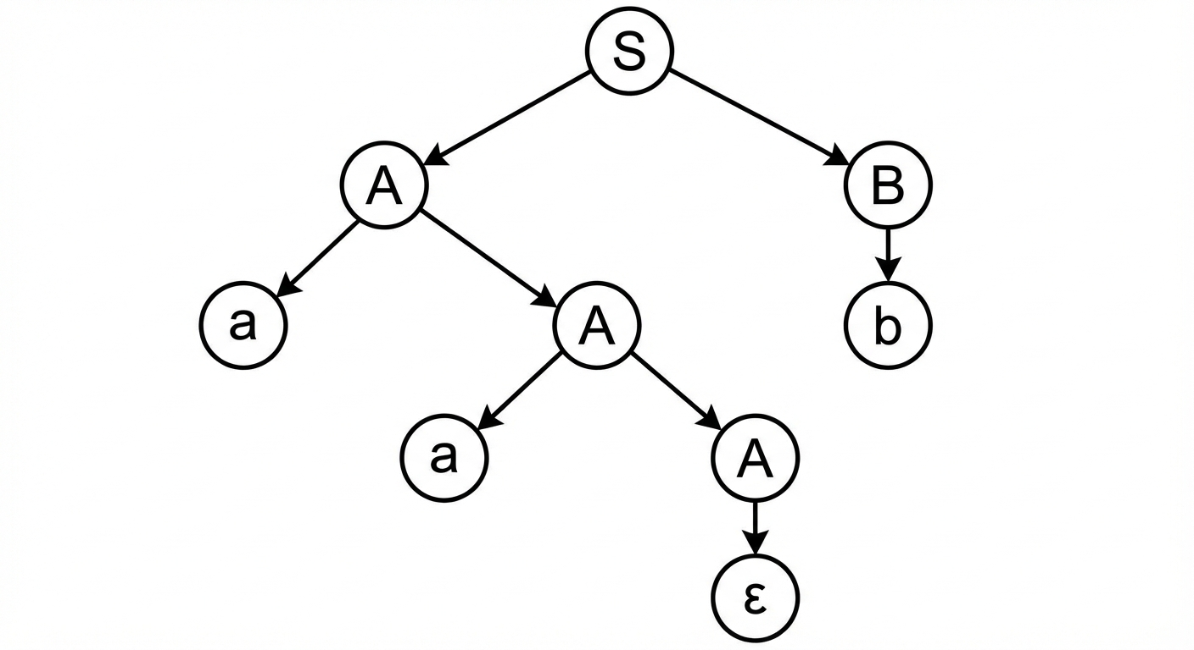

4. Breakdown of the Tree
- Root Node (S): The start of the expression, splitting into components A and B.
- Left Branch (A): * The first A produces a and a new A.
  - The second A produces another a and a third A.
  - The final A produces ε (null), terminating the "a" sequence.
- Right Branch (B): * The B produces the single terminal b.
- Yield: Reading the leaves from left to right: a → a → ε → b, which simplifies to "aab".

5. 5. Summary Table

Step | Rule Applied | Current String
1 | S → AB | AB
2 | A → aA | aAB
3 | A → aA | aaAB
4 | A → ε | aaB
5 | B → b | aab

